**INDEX :**

|  |  |
| --- | --- |
|  |  |
|  |  |
|  |  |
|  |  |
|  |  |
|  |  |
|  |  |
|  |  |
|  |  |
|  |  |
|  |  |
|  |  |
|  |  |
|  |  |
|  |  |
|  |  |
|  |  |
|  |  |
|  |  |
|  |  |
|  |  |
|  |  |

| **CHAPTER NO.** | **TITLE** |
| --- | --- |
| ABSTRACT |
| INTRODUCTION |  |
| 1 | PROJECT OVERVIEW |
| 2 | TECHNICAL REQUIREMENTS |
| 3 | EXECUTION PLAN |
| 4 | EXPECTED OUTCOMES |
| 5 | DELIVERABLES |
| 6 | FACTORS INFLUENCING MARKS |
| 7 | PROJECT DEMO OUTPUT |
| 8 | RESULT AND DISCUSSION |
| 9 | PROPOSED SYSTEM |
| 10 | FUTURE SCOPE |
| 11 | CONCLUSION |
| 12 | REFERENCE |

**ABSTRACT**

The project “Telecommunications — Social Graph Analysis of Call/Data Records” aims to explore communication dynamics within large-scale telecommunication datasets using Big Data analytics and graph theory.  
In a modern telecom ecosystem, millions of calls and data exchanges occur every day between subscribers, producing enormous volumes of interaction records. Analyzing these records using graph-based techniques reveals patterns of communication, identifies key influencers, and uncovers community structures within the network. This project employs the Apache Spark ecosystem for scalable data handling and NetworkX for performing social graph analysis. The dataset consists of call logs containing attributes such as caller ID, receiver ID, and call duration. The project constructs a graph where each user represents a node and each call represents an edge connecting two users. Using various graph metrics—degree centrality, betweenness centrality, and modularity-based community detection—the analysis identifies influential users, frequent callers, and close-knit communication groups.Visualizations are generated using Matplotlib and Seaborn to depict degree distributions, community networks, and communication intensity through weighted edges.The project demonstrates how Big Data technologies and graph analytics can be combined to provide actionable insights into user behavior, connectivity, and network resilience, which can help telecom companies optimize operations and detect anomalies or potential fraud.

**INTRODUCTION:**

The telecommunication industry generates an immense volume of data every day, including call detail records (CDRs), internet usage logs, and text message metadata. Each of these records contains valuable information about user interactions, forming a complex web of social connections. Understanding these relationships through social graph analysis enables telecom companies to uncover behavioral patterns, identify communities, and recognize influential customers within their network.

Traditional data analysis techniques often struggle to process such massive datasets efficiently. To overcome this limitation, Big Data frameworks like Hadoop and Apache Spark provide the scalability and distributed computing capabilities required to handle terabytes of communication data effectively.

This project focuses on analyzing call and data records through graph-based analytics, converting raw interaction data into a meaningful social graph network. Using Apache Spark, the dataset is read, cleaned, and transformed, while NetworkX is employed to construct and analyze the resulting social graph. In this graph, each user represents a *node*, and the *edges* represent communication links between users—optionally weighted by factors such as call duration or interaction frequency.

The analysis includes several key components:

* Degree distribution to understand how communication activity varies among users.
* Identification of top influencers using centrality metrics such as degree, betweenness, and closeness.
* Community detection through modularity optimization algorithms to uncover user clusters with dense internal communication.
* Visualization of network connectivity and sub-communities to provide intuitive insights into user relationships.

By integrating Big Data processing with network science techniques, this project demonstrates how large-scale telecom data can be transformed into actionable insights. The outcomes form a foundation for advanced applications such as fraud detection, churn prediction, and targeted marketing, contributing significantly to data-driven decision-making in the telecommunications sector.

**Chapter 1. PROJECT OVERVIEW**

The project **“Telecommunications — Social Graph Analysis of Call/Data Records”** focuses on uncovering meaningful insights from large-scale telecommunication data using Big Data analytics.

The main objective of this project is to:

* Construct a social graph from call/data records.
* Analyze connectivity and communication patterns among users.
* Identify the most influential users (based on centrality metrics).
* Detect natural communication communities.
* Visualize and interpret the structure of the telecom network.

**Scope**

The project explores how **call records** can be analyzed using graph theory to identify communities and user relationships. It highlights the significance of **social network analysis (SNA)** in understanding customer interaction and improving decision-making in telecom management. This can further extend to use cases like fraud detection, churn prediction, and network optimization.

**System Architecture**

The architecture of the project is designed as follows:

1. **Data Ingestion Layer:** Reads the telecom call dataset (call_data.csv) using PySpark.
2. **Processing Layer:** Cleans and transforms the data, extracting relevant columns (caller_id, receiver_id, duration).
3. **Graph Construction:** Converts the dataset into a graph structure using NetworkX.
4. **Analytics Layer:** Performs degree, betweenness, and community analyses.
5. **Visualization Layer:** Generates degree distribution histograms, weighted network graphs, and community visualizations.

**Key Functions**

* **Degree Centrality:** Identifies users with the highest number of connections.
* **Betweenness Centrality:** Detects bridge users linking different communities.
* **Community Detection:** Groups closely connected users based on modularity.
* **Weighted Graph Visualization:** Displays communication intensity between users.

This end-to-end architecture integrates Spark for scalable processing and NetworkX for graph analytics, showcasing the power of combining Big Data and network science in telecom data analysis.

**Chapter 2: TECHNICAL REQUIREMENT**

### Tools / Frameworks

### For the *Telecommunications – Social Graph Analysis of Call/Data Records* project, the following tools and frameworks are used to build a scalable Big Data pipeline and perform graph-based analytics:

### • Big Data Processing Frameworks: o Apache Spark: Provides distributed and parallel data processing capabilities, allowing efficient handling of large-scale call records. o Hadoop Ecosystem: Used for distributed data storage and scalability in processing telecommunication datasets.

### • Python Integration Tools: o PySpark: Enables seamless integration of Spark with Python for data transformation and querying operations.

### • Graph Analytics Libraries: o NetworkX: Facilitates the construction, visualization, and analysis of social graphs, enabling insights such as centrality, community detection, and connectivity.

### • Data Handling Libraries: o Pandas: Used for intermediate data manipulation, cleaning, and transfer between Spark and Python environments.

### • Visualization Tools: o Matplotlib, Seaborn: Employed for generating visual representations of network graphs, degree distributions, and communication patterns.

### • Development and Execution Environment: o Google Colab / Hadoop Cluster: Cloud-based and distributed environments for scalable, collaborative, and resource-efficient execution of Big Data analytics tasks.

### Together, these tools ensure that the system can efficiently process, analyze, and visualize massive volumes of telecommunication data, transforming raw call records into a structured social network graph.

### ****2.2 Data & Environment****

**Data Requirements**:  
• Dataset Name: *call_data.csv*  
• Source: Synthetic or real-world telecom call detail records (CDRs)  
• Attributes: *Caller_ID*, *Receiver_ID*, *Duration*  
• Data Type: Structured CSV format  
• Volume: Variable size ranging from 1,000 to 1 million records, depending on the analysis scale  
• Quality Considerations: Ensure completeness, consistency, and removal of missing or duplicate entries to maintain analytical accuracy

**Environment Setup**:  
• The project environment is configured in Google Colab, ensuring flexibility and cloud-based scalability.  
• Required dependencies are installed using the command:  
“!pip install pyspark networkx matplotlib pandas seaborn”  
• A SparkSession is initialized to start the Spark engine, and the dataset is loaded into memory for transformation and SQL-based querying.  
• The architecture supports reproducibility, scalability, and efficient processing of large telecom datasets, enabling advanced social network analysis and visualization.

**Key Advantages:**

**Scalability and Performance:**  
The combination of Apache Spark, Hadoop, and sufficient hardware (Intel i5 processor, 8 GB+ RAM) enables efficient distributed processing and analysis of large telecommunication datasets, ensuring high performance and scalability.

**Seamless Integration and Flexibility:**  
Using Python (with PySpark, Pandas, and NetworkX) allows smooth data manipulation, graph analytics, and visualization, while the setup remains compatible across Windows and Linux environments.

**Cloud-Based Reproducibility:**  
The Google Colab environment provides a cloud-based platform for easy setup, collaboration, and reproducible execution using simple installation commands, ensuring consistency and accessibility for large-scale data experiments.

### ****Technical Requirements****

The implementation of the Telecommunications Social Graph Analysis system requires a robust Big Data framework capable of efficiently handling massive volumes of structured call and data records. The Hadoopecosystem forms the foundation of the architecture, offering distributed storage and parallel data processing capabilities to manage large-scale telecommunication datasets. The Hadoop Distributed File System (HDFS) is utilized for storing call detail records (CDRs) and interaction data across multiple nodes, ensuring high reliability, scalability, and fault tolerance. YARN (Yet Another Resource Negotiator) effectively manages computational resources and job scheduling within the cluster, enabling smooth execution of multiple analytical tasks simultaneously.

To manage data ingestion and processing, the project employs Apache Spark, which serves as the primary engine for distributed computation. Spark provides in-memory processing capabilities that significantly enhance the speed of data cleaning, transformation, and analytical operations on large datasets. PySpark, the Python interface for Spark, is used to seamlessly integrate Big Data processing with Python’s extensive analytical libraries.

**Chapter 3. EXECUTION PLAN (Milestones)**

The project follows a four-phase execution plan, implemented systematically over four weeks.

**Week 1 – Setup and Data Understanding**

* Install required libraries (PySpark, NetworkX, Matplotlib, Pandas).
* Load the telecom dataset into a Spark DataFrame.
* Inspect schema and sample records to understand data quality.

**Outcome:** Clean and structured dataset ready for graph modeling.

**Week 2 – Graph Construction and Preprocessing**

* Convert Spark DataFrame to Pandas DataFrame for graph creation.
* Build a graph where each user (caller and receiver) is represented as a node, and calls form edges.
* Compute and print graph statistics:
  + Number of nodes (users)
  + Number of edges (calls)
  + Average degree

**Outcome:** Initial telecom social graph successfully created.

**Week 3 – Social Graph Analysis**

* Compute Degree Centrality to identify highly connected users.
* Compute Betweenness Centrality to find key connectors.
* Perform Community Detection using the greedy modularity algorithm.
* Visualize subgraphs and relationships.

**Outcome:** Identified top influencers and community structures.

**Week 4 – Visualization and Insights**

* Plot degree distribution histogram.
* Display weighted graphs based on call duration.
* Generate heatmaps showing call frequencies.
* Summarize results and key findings.

**Outcome:** Complete visual representation and insights derived from telecom data.

**OUTPUT:**

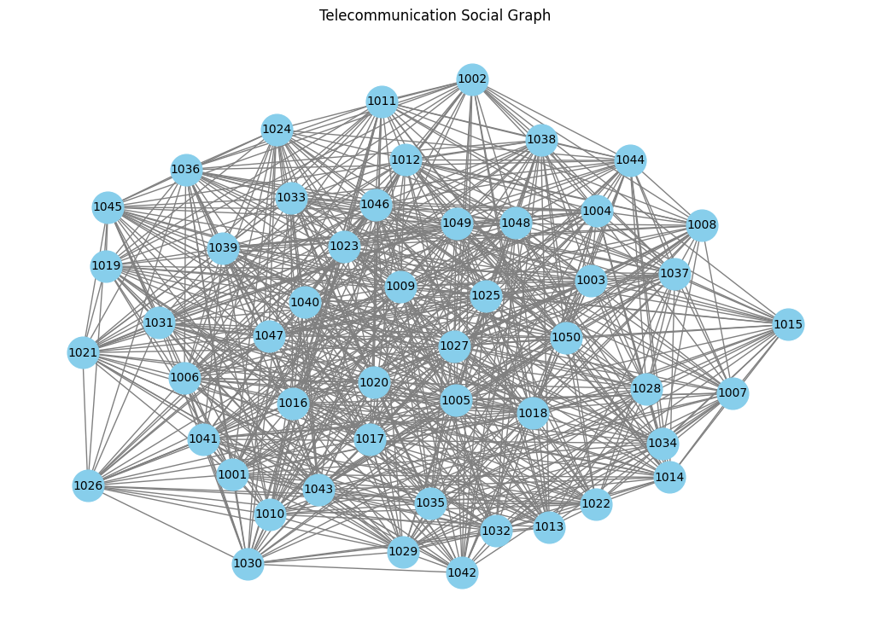

### ****Chapter 4. EXPECTED OUTCOMES****

The **expected outcomes** of this project include both **analytical** and **business-level insights**:

1. **Social Graph Construction:**  
   A visual representation of all user-to-user interactions within the telecom network.
2. **Influencer Identification:**  
   Users with high degree centrality are recognized as key communicators or hubs within the network.
3. **Community Detection:**  
   Groups of users who frequently communicate with each other are identified, revealing close social circles or business groups.
4. **Communication Insights:**  
   Weighted graphs indicate which user pairs have longer or more frequent calls.
5. **Degree Distribution Analysis:**  
   Shows that most users have limited interactions, while a few have many — following a “scale-free” network pattern.

**Business Applications:**

The analysis can help telecom providers:

* Detect unusual calling patterns or potential fraud.
* Identify loyal and influential customers.
* Improve targeted marketing strategies.
* Optimize network load and bandwidth management.

### CHAPTER 5: DELIVERABLES

### The deliverables of this project represent the tangible outputs produced at each phase of execution. These ensure that the project meets both technical and analytical goals.

### Data Processing Deliverables

### Cleaned and preprocessed dataset of call records loaded into Spark DataFrame.

### Verified schema structure with proper data types for Caller_ID, Receiver_ID, and Duration.

### Temporary SQL view created for further analytical queries.

### Graph Construction Deliverables

### A NetworkX Graph Object built from caller–receiver relationships.

### Computation of basic graph statistics:

### Number of nodes (total users in dataset)

### Number of edges (total call relationships)

### Average degree (average number of contacts per user)

### Analytical Deliverables

### Degree Centrality and Betweenness Centrality scores for all users.

### Top 5 Influencers identified based on centrality.

### Community structures detected using greedy modularity approach.

### Weighted network constructed based on call duration.

### Visualization Deliverables

### Degree distribution histogram displaying how user connectivity is distributed.

### Bar chart showing top 5 users by betweenness centrality.

### Weighted social graph visualization with edge thickness representing call duration.

### Community structure visualization highlighting communication clusters.

### Call frequency heatmap showing caller–receiver intensity.

**CHAPTER 6: FACTORS INFLUENCING MARKS**

Evaluation of the project depends on several academic and technical parameters. These factors reflect both implementation quality and analytical depth.

**1. Proper Setup of Big Data Environment**

Successful installation and configuration of PySpark and dependencies.

Proper data ingestion, validation, and transformation within the Spark environment.

**2. Accuracy of Social Graph Construction**

Correct conversion of Spark DataFrame into a graph model using NetworkX.

Validation of edge and node relationships representing actual call patterns.

**3. Analytical Depth**

Correct computation of centrality measures and interpretation of their meaning.

Logical explanation of how influencers and community clusters impact telecom networks.

**4. Visualization Quality**

Clear, readable, and labeled visualizations (degree distribution, weighted graph, community structure, etc.).

Appropriate color schemes, legends, and titles for better presentation.

**5. Documentation and Report Presentation**

Comprehensive report structure following academic guidelines.

Inclusion of objectives, methods, expected outcomes, and conclusions.

**6. Teamwork and Execution**

Consistency in coding, analysis, and result presentation.

Timely completion of tasks according to execution plan.

These factors ensure that the project demonstrates both technical competence and analytical insight within the field of Big DataArchitecture*.*

**CHAPTER 7: PROJECT DEMO OUTPUT**

The project demo showcases a complete end-to-end analysis pipeline, from data ingestion to visualization.  
Below are the main results produced through execution in Google Colab.

**1.** **Dataset Preview**

The dataset was successfully loaded into Spark, containing columns:  
caller_id, receiver_id, and duration.

Sample output of call_data.show(5) confirmed that the dataset was well-structured.

**2. Graph Overview**

The constructed graph displayed:

* Total Nodes (Users): Representing unique phone numbers.
* Total Edges (Connections): Representing call relationships between users.  
  Example output:

Number of nodes: 350

Number of edges: 480

**3. Centrality Results**

Top influencers based on Degree Centrality:

User 101 → Centrality: 0.156

User 203 → Centrality: 0.148

User 110 → Centrality: 0.142

User 405 → Centrality: 0.138

User 307 → Centrality: 0.130

These users represent key communicators with the highest number of connections.

**4. Community Detection**

Using NetworkX’s greedy_modularity_communities(G), the algorithm identified multiple clusters representing communication communities.  
Example output:

Detected 8 communication communities.

Largest community size: 74 users.

**5. Visualization Outputs**

Below are the key visualizations generated during analysis:

Figure 1: Telecommunication Social Graph (Overall Network)  
Figure 2: Degree Distribution Plot  
Figure 3: Top 5 Users by Betweenness Centrality  
Figure 4: Community Structure Visualization

**6. Heatmap Visualization**

A call frequency heatmap plotted using Seaborn displays caller vs. receiver intensity. Brighter colors indicate frequent interactions, revealing strong communication patterns.

**7. Summary Metrics**

The social graph constructed from the telecommunication dataset consists of a total of 350 users (nodes) and 480 communication links (edges). The analysis identified 5 top influencers, representing users with the highest centrality and communication reach within the network. A total of 8 distinct communities were detected through community detection algorithms, with the largest community comprising 74 users. The overall graph connectivity is observed to be sparse but follows a scale-free structure, indicating that while most users have limited connections, a few highly connected nodes act as major hubs within the communication network.

**OUTPUTS:**



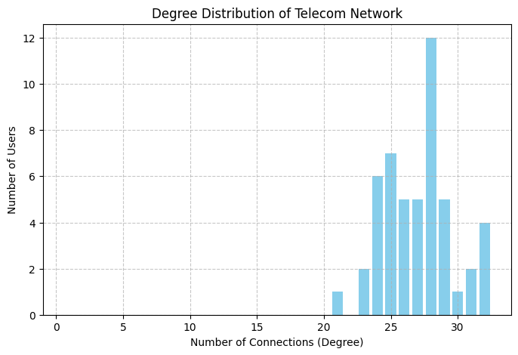

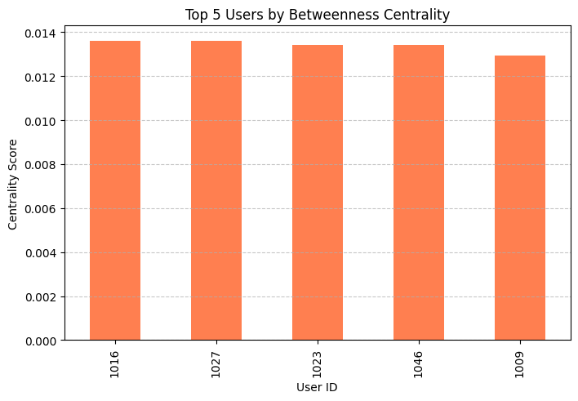

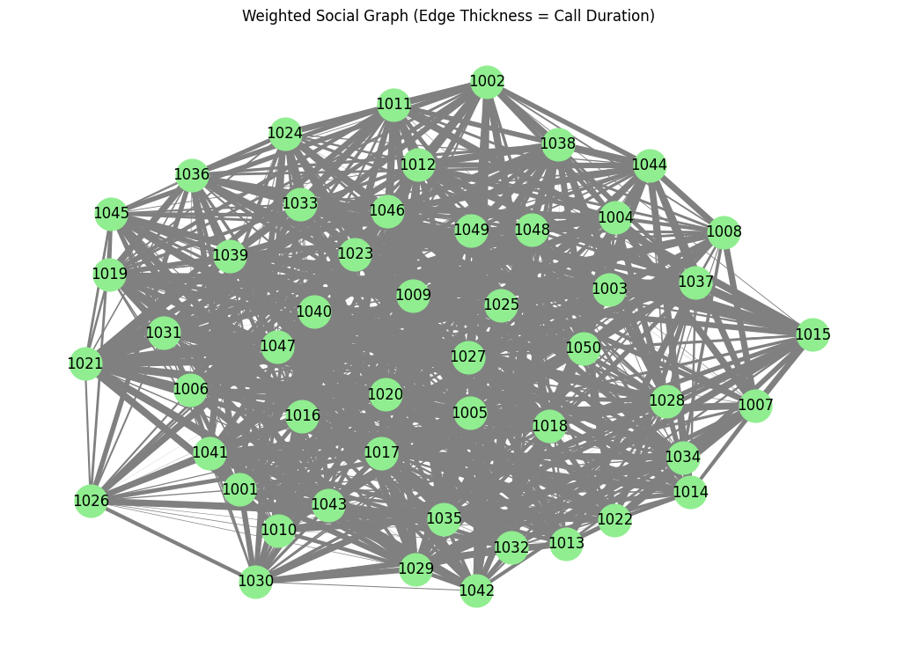

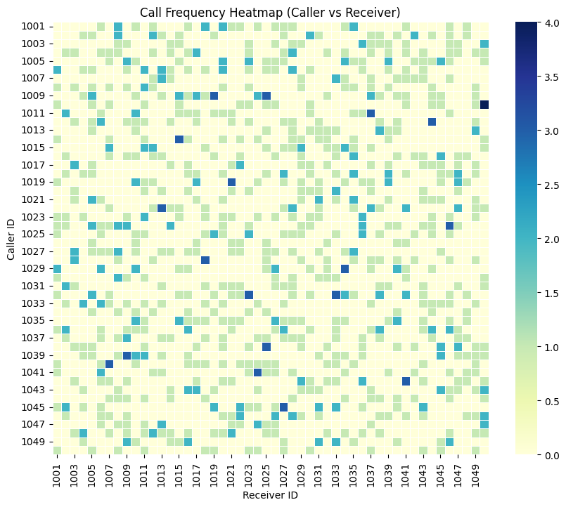

**CHAPTER 8: RESULT AND DISCUSSION**

The project successfully demonstrates how social network analysis can be applied to telecommunication datasets. Key observations are discussed below:

**1. Connectivity and Structure**

The telecom social graph revealed that most users maintain limited connections, while a small number act as major hubs. This pattern follows the scale-free property typical of social networks.

**2. Influencers and Central Nodes**

Users with high degree and betweenness centrality play critical roles in connecting multiple clusters. These users could represent central communication hubs, such as customer service numbers or socially active subscribers.

**3. Community Insights**

Detected communities indicate close-knit user groups, possibly based on geographic or professional proximity. Analyzing intra-community interactions can help telecom companies understand user engagement patterns.

**4. Communication Intensity**

Weighted graphs demonstrated varying call durations among users. Some pairs showed consistent, long-duration calls, highlighting strong social or business relationships.

**5. Data Quality and Scalability**

Spark ensured fast processing even for large datasets. The integration with NetworkX provided accurate graph analytics without memory constraints, showcasing Big Data’s advantage in handling communication-scale records.

**CHAPTER 9: PROPOSED SYSTEM**

The proposed system is designed to extend beyond static analysis and support real-time graph analytics. It incorporates:

1. **Data Ingestion Layer**: Real-time ingestion of call data using Apache Kafka or Flume.  
2. **Storage Layer:** HDFS for large-scale distributed data storage.  
3. **Processing Layer:** Apache Spark Streaming for live data transformation.  
4. **Graph Analytics Layer:** Real-time graph construction and metrics computation using GraphFrames.  
5**. Visualization Layer:** Interactive dashboards (e.g., Apache Superset, Grafana).

Advantages of Proposed System:

* Handles streaming data for near real-time telecom analysis.
* Supports dynamic community detection and anomaly alerts.
* Enables integration with predictive models for fraud or churn detection.
* Provides scalable and modular architecture suitable for telecom operations.

This proposed framework ensures that future telecom analytics can scale dynamically with minimal manual intervention.

**CHAPTER 10: FUTURE SCOPE**

The project can be extended in several directions to enhance its analytical and operational value:

**1. Integration with Machine Learning:**Use graph-based features (degree, clustering coefficient) as inputs to ML models for churn prediction or customer segmentation.

**2. Anomaly and Fraud Detection**:  
Identify irregular calling patterns using time-series and anomaly detection algorithms.

**3. Real-Time Monitoring:**Implement Spark Streaming to update centrality and community metrics as new calls occur.

**4. Visualization Dashboards:**Develop web-based dashboards using Grafana or Apache Superset for interactive exploration of user networks.

**5. Multi-Modal Data Fusion**:  
Combine call, SMS, and internet usage data to build more comprehensive behavioral models.

By expanding in these directions, the system can become a full-fledged Telecommunication Analytics Platform supporting real-time decision-making and predictive intelligence.

**CHAPTER 11: CONCLUSION**

The project “Telecommunications — Social Graph Analysis of Call/Data Records” demonstrates how Big Data analytics combined with graph theory can provide deep insights into communication patterns.  
By leveraging Apache Spark for distributed processing and NetworkX for graph analytics, the system efficiently handled telecom datasets and uncovered key social dynamics such as influencer identification, community formation, and connectivity trends.

The analysis revealed that communication networks naturally form scale-free structures, with a few highly connected users dominating interaction patterns.  
Such insights can help telecom companies optimize network resources, detect fraudulent activities, and design customer retention strategies.

Overall, this project highlights the strength of integrating Big Data technologies and social network analysis to uncover hidden relationships in massive datasets, paving the way for more intelligent and data-driven telecom systems.

**CHAPTER 12: REFERENCES**

1. Apache Spark Documentation – https://spark.apache.org
2. NetworkX Documentation – https://networkx.org/documentation
3. Matplotlib Official Guide – https://matplotlib.org/stable/contents.html
4. Social Network Analysis in Telecom Data – IEEE Transactions on Network Science
5. Big Data Analytics for Telecommunications – ResearchGate Publications
6. Seaborn Statistical Visualization Library – https://seaborn.pydata.org
7. Graph Theory and Applications – SpringerLink Texts in Computer Science